**Parents’ And Instructors’**

**Notifications System**

**(PAINS)**



**Group members:**

Mohsin Ammar 36446

Jamal Hassan Sargana 35052

Affan Muddassir 6987

**Abstract:**

Parents’ and instructors’ notification system or PAINS is an online portal aimed to *bridge* the *increasing communication gap* between instructors and parents regarding the academic know-how of students. The portal is finely suited to the *dynamics* of the *general Pakistani public* with *only the instructors* needing to learn to use the portal. Parents, on the other hand, will simply receive all the information about their children on a weekly/regular basis via *SMS*.

**Introduction:**

The standards of education in our country are very adverse particularly when it comes to *schools and colleges*. The ratio of students to teachers is very alarming with class rooms sometimes being filled to their very neck by students. The *quality of teaching* leaves a lot to be desired as well with teachers mostly concerned with ensuring that the students memorize or *‘ratta-fy’* everything rather than understanding what they’re studying.

There’s *no check* on attendance, parent teacher meetings or any other criteria that ensures that parents are *continuously updated* about the progress of their child. This allows many students to take the school/college for granted as parents remain un-informed about whatever is going on with regards to the academics of their children and skip the school/college at will. The aim of our project is to *bridge that gap* keeping in perspective *the technological constraints* in our country i.e. parents or teachers not being able to use the Internet or other technologies and introduce something that not only government school/colleges teachers can easily operate but will also keep parents updated without having to go through any sort of fuss.

**Problem Statement:**

A solution/bridging the tremendous *communication gap between parents and teachers* particularly in government schools/colleges.

**Our Solution:**

Our solution to this problem is the development of an *online portal* that will be made available to teachers through the internet. Teachers will register themselves on the portal and then will be able to maintain an *online record of the day-to-day activities* of each and every student in his/her class. This record can include the students’ attendance, grades in any assessment, announcements or any comments the teacher wishes to send to the parents.

The entire report will be entered into the portal by the instructor. To make it easy for parents and teachers alike, the report will be sent to the parents on their *mobile number via SMS* in *a language understandable to them*. We’ll make use of an API that’ll allow the portal to send the information via SMS while the instructor will simply press SEND on the portal after selecting a valid mobile number. This means that *only the instructors* will require training on how to operate that portal while parents will not have to worry about a single thing and instead will remain periodically informed about their child’s academics on their mobile phones.

**Literature Review:**

The most important aspect we’ve kept in mind when coming up with this idea is that government schools/colleges see majority of students from families who’re *less to not educated at all*. Hence, we wanted to come up with something that won’t be a hassle to parents and instructors alike while also serving the purpose we’re developing it for.

Of course the instructors will require training as they’ll be the ones in the driving seat but to balance this out, parents will simply get all the information on their mobile phones. Mobile phones or smartphones are *more common than computers* in Pakistan which is why we’ve decided to focus our attention on getting the information to the parents via their mobile devices. Instead of an online portal where they could come and view all the information, all the content will be sent to them via text in *Urdu* or *English* as the probability of computers and the Internet being in most homes is comparatively lesser to mobile phones. They won’t need smartphones to make use of this service which is what most systems that are currently operating in the country *lag* nowadays. They require parents to log-in and register themselves for using its services which is what PAINS nullifies.

**Design and implementation:**

**Technologies used:**

AngularJS and Angular Material for front-end and PHP for back-end.

**Unit-testing:**

All Unit-testing done through ***Postman***:

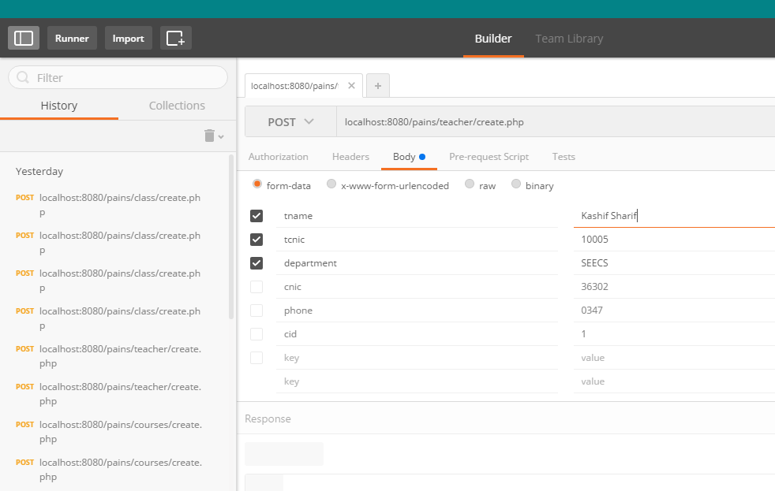

Teacher table before addition:

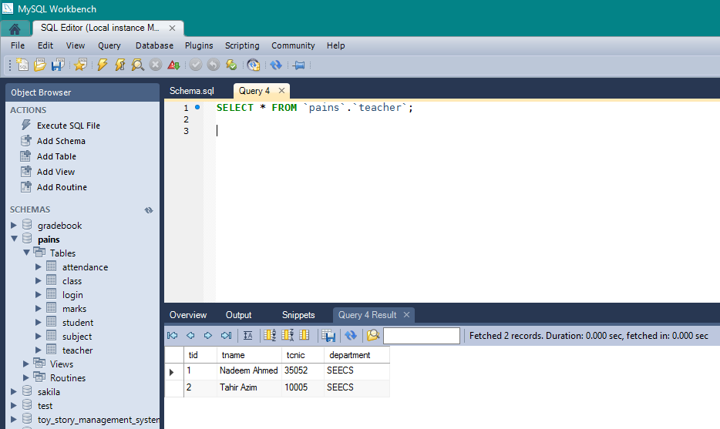

Teacher table after addition:

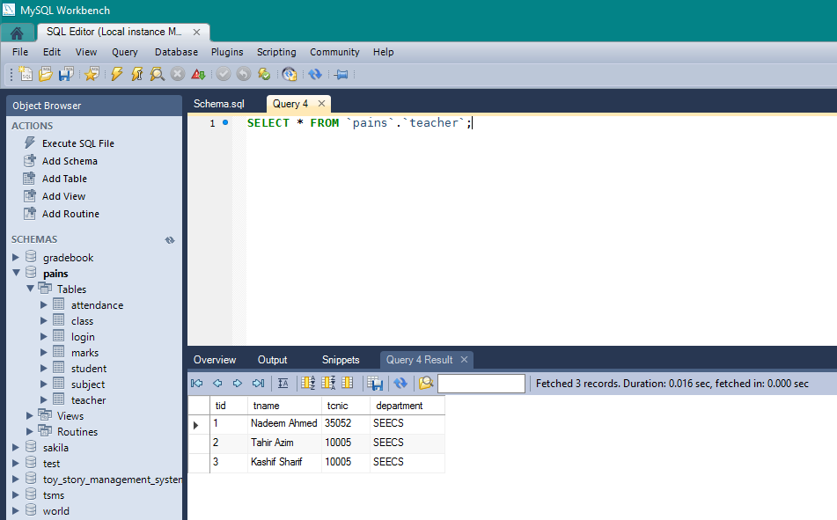

Similarly, for student table:

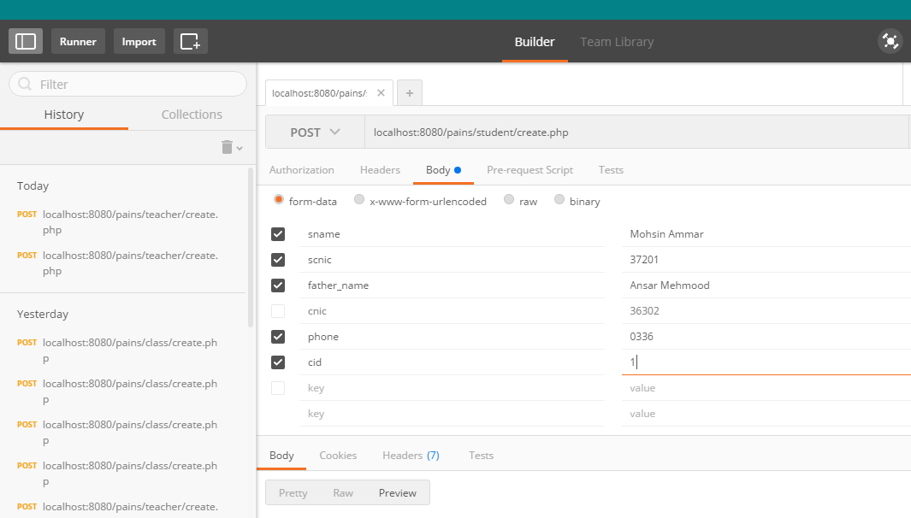

Before insertion:

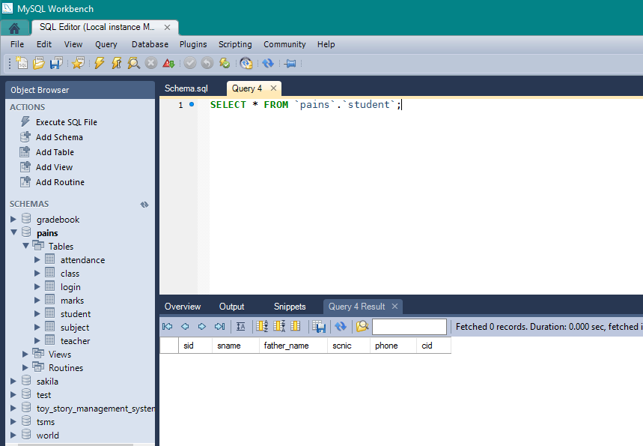

After insertion:

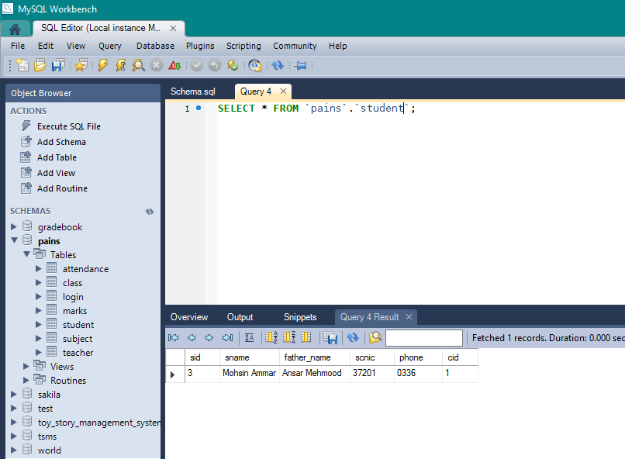

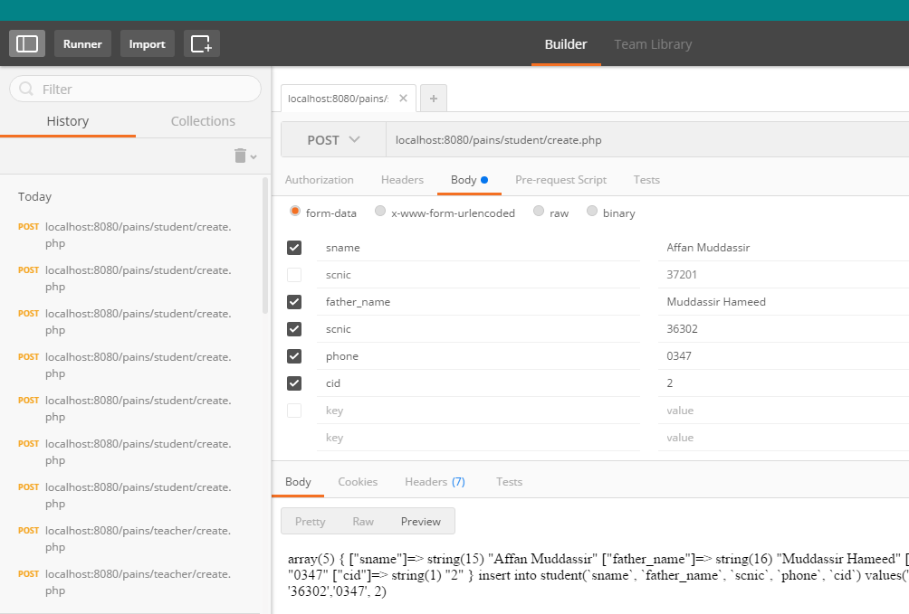

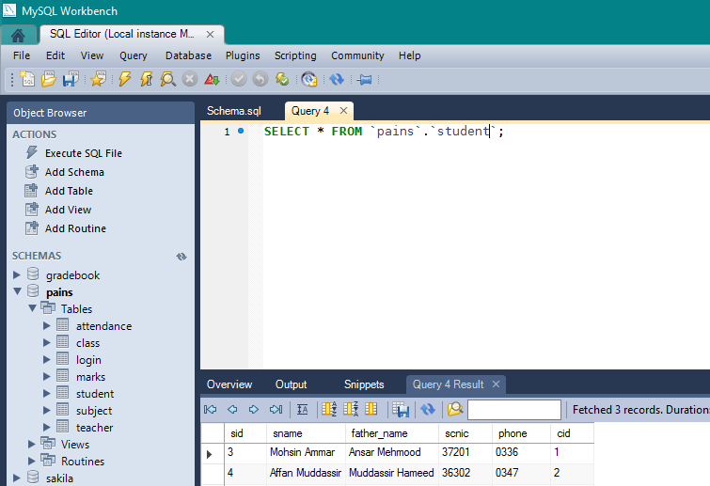

For class:

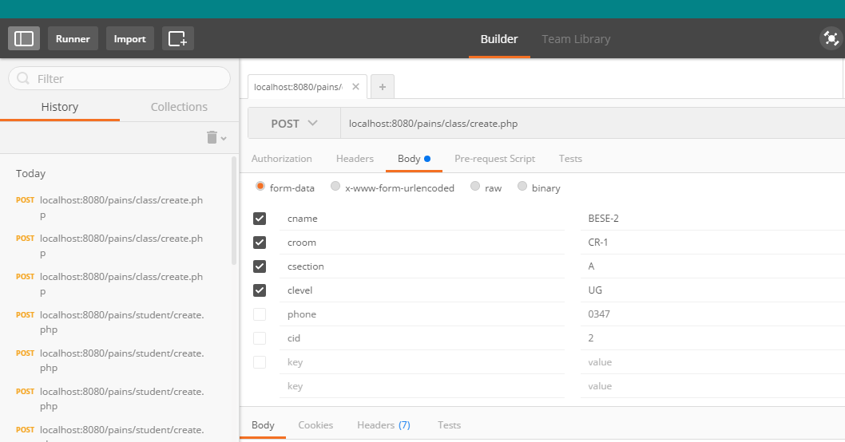

Before addition:

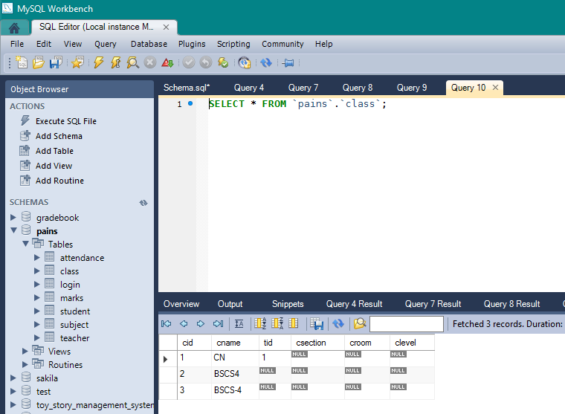

After addition:

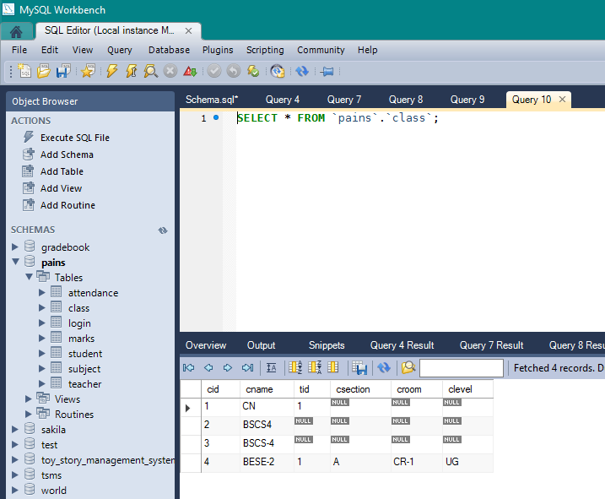

**Conclusion:**

The project’s successful completion is a huge a relief for us. This is mostly down to the fact that we were able to build such a system in the most jam-packed of academic schedules. Furthermore, we aim to deploy this system in many small institutions to ensure that PAINS fulfills its due promise and indeed bridges the gap between parents and instructors all over our country.